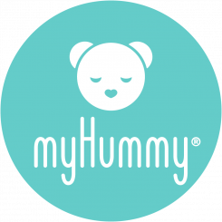
Returns Form

You may return an item to us for an exchange or refund providing that:

- You return the item to us within 28 days of receiving your order
- The goods are re-saleable, unused and in their original packaging with all tags and labels intact
- If any item is incorrect, faulty or damaged on receipt, please let us know immediately when you receive the item by emailing hello@myhummy.co.uk or calling 01278 434440

Personalised products are non-refundable and non-exchangeable.

We cannot accept your return if:

- This form is not completed and returned alongside the item/s
Please supply the following information and return with your item/s:

Order number | SO
Name
Daytime phone number
Email
Postcode

Return reason codes:

1 | Unsuitable / Don’t like – please add note | 4 | Wrong item sent
2 | Damaged / Faulty – please add note | 5 | Quality – please add note
3 | Arrived too late | 6 | Other – please add note
Notes:

Item/s returned:

Item Code | Qty | Description | Reason Code | Exchange/Refund | Value

Exchange item/s required: – there is no additional postage to pay for exchanges

Item Code (see website) | Qty | Description | Reason Code | Exchange/Refund | Value

Please note that Hippychick Ltd is unable to pay for the cost of returning goods, unless they are faulty, damaged or incorrectly dispatched. We cannot accept responsibility for returned items which do not reach us. Therefore, we recommend that you send returns via the Post Office by Recorded or Special Delivery, returning your proof of postage. This returns policy is in addition to your Statutory rights. We do process returns as fast as possible, however during busy times, if you urgently need replacement items, we suggest you contact us – 01278 434440 or hello@myhummy.co.uk

